ASR 6875

**From:** Marcus, Tong   
**Sent:** Monday, 27 November 2017 4:07 PM  
**To:** Chan, Pei-Fong <[pei-fong.chan@dbschenker.com](mailto:pei-fong.chan@dbschenker.com)>  
**Cc:** Marcus, Tong <[marcus.tong@dbschenker.com](mailto:marcus.tong@dbschenker.com)>  
**Subject:** RE: Scan detail 305372L.0FL

Hi Pei Fong,

Please see my remark on the below.

-          Can OFI prompt the leadership when the team member hit any error in OFI ?

        PF: How do you prefer system to prompt leader?

Replied: A email alert to leadership when they is a error for releasing.

-          When there is error for this SOLI, can block all user to proceed instead on just that user?

            PF: once there’s any error scan, system will block continue scanning of the SO/Line?

Replied: Yes, Once error prompt for release, the whole SOLI will be block till leadership release, even continues next box is also not acceptable.

Thank And Best Regard,

Marcus Tong

SKH / VAS Executive

Contract Logistics/SCM, Operation

# Request:

OFI PACKING- Error Scan control:

-          When there is error for this SOLI, can block all user to proceed instead on just that user?

            PF: once there’s any error scan, system will block continue scanning of the SO/Line?

Replied: Yes, Once error prompt for release, the whole SOLI will be block till leadership release, even continues next box is also not acceptable.

Changes:

Object – OFI Scanning – Packing (u_micron_ofi_scanlabel)

* To block continue scanning if there’s Error scanning for the SO / Line

TEST case:

SO 60231002(100)

1. When error scan in one of the LotID :

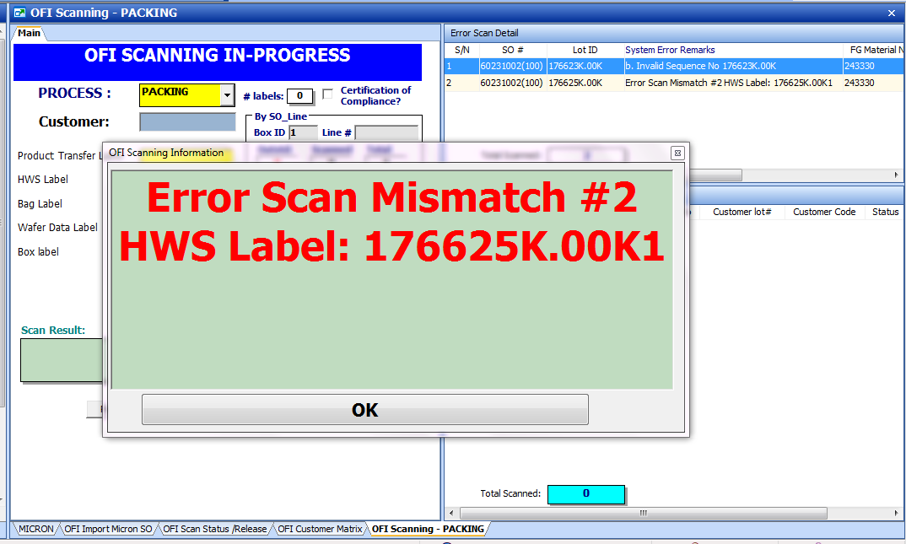

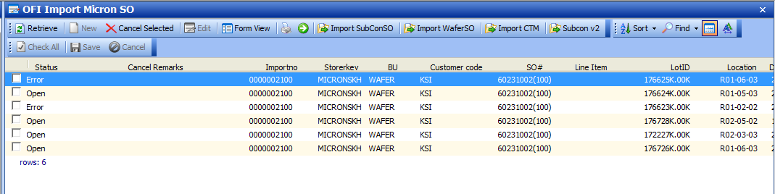

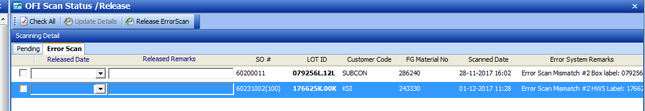

1. Continue scan Box2 – not allowed.

